Account Management Assignment

Mule 4

|  |  |
| --- | --- |
|  |  |
|  |  |

# Table of Contents

Table of Contents 2

1. Introduction 2

2. Data flow of Account Payload 3

3. Database structure 4

4. Developer Notes 4

4.1. Source Control 4

# Introduction

This document describes implementing account management scenario using Mulesoft. We have JSON payload and need persist data into database.

# Data flow of Account Payload

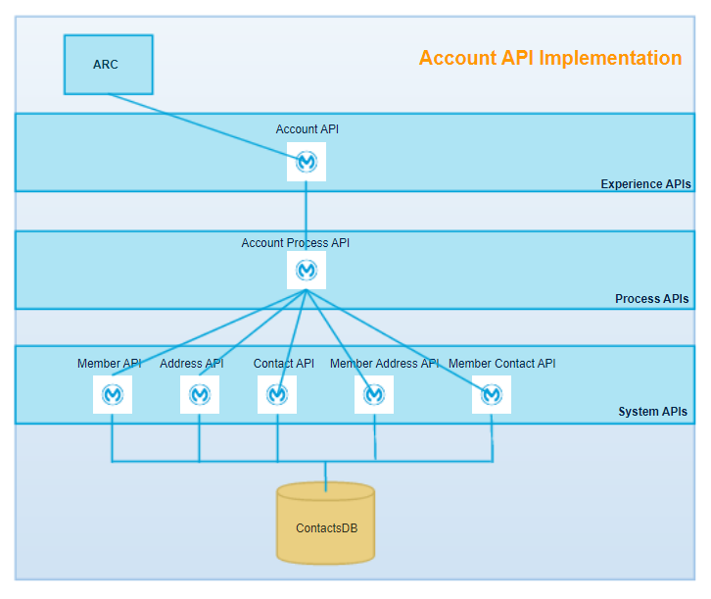

# Database structure

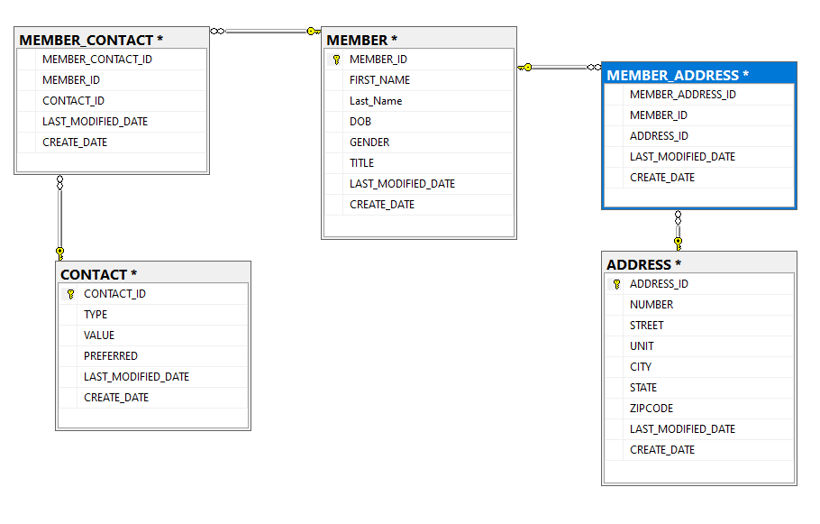

# Developer Notes

## Source Control

<https://github.com/rkvajrala/MS3ContactManagement>

* Need to deploy using Mule 4
* Need Microsoft SQL Server to run Db Scrits
* Once you deploy application locally. You can submit to request to Account API
  + Account API is an Expeience API to submit the payload
    - <http://localhost:8092/api/account>
  + Account appi will call Account Process API
    - <http://localhost:8093/proceeaccount>
  + Account Process API will System API to get member,address and contact resprctively
    - <http://localhost:8082/api/Member>
    - <http://localhost:8083/api/Address>
    - <http://localhost:8084/api/contact>
    - <http://localhost:8090/api/member_address>
    - <http://localhost:8091/api/member_contact>